Design
System design is the process of transforming the software requirements into a detailed blueprint that defines the architecture, components, data flow, interaction diagrams, and implementation guidelines.
For this project, the design focuses on how the hybrid automation framework handles Web + Mobile, executes tests, detects broken locators, heals them using AI-based strategies, and generates detailed reports.

4.1 Architectural Design
The architecture of the proposed Hybrid Automation Framework is designed in a modular, extensible, and platform-independent manner. It consists of six major layers:
1. Test Layer
- Contains test scripts written using TestNG / JUnit
- Supports Web + Mobile test cases
- Follows Page Object Model (POM) / Screen Object Model (SOM)
2. Driver Management Layer
- Launches Selenium WebDriver for web
- Launches Appium Driver for Android/iOS
- Supports parallel execution using thread-local driver factory
3. Self-Healing Engine (Core Component)
- Intercepts element-not-found exceptions
- Performs DOM similarity analysis
- Applies fallback locator strategies
- Generates new locator dynamically
- Returns “healed locator” so execution continues without failure
4. Locator Analysis Module
- Extracts DOM attributes
- Matches elements using weighted scoring
- Evaluates XPath heuristics and visual cues
- Stores locator history for improvements
5. Reporting & Analytics Module
- Generates HTML / Extent / Allure reports
- Stores screenshots, logs, healing attempts
- Displays stability index, flaky test detection
6. CI/CD & Integration Layer
- Integrates with Jenkins using pipelines
- Pushes reports automatically
- Supports version-controlled execution

4.2 System Architecture Diagram
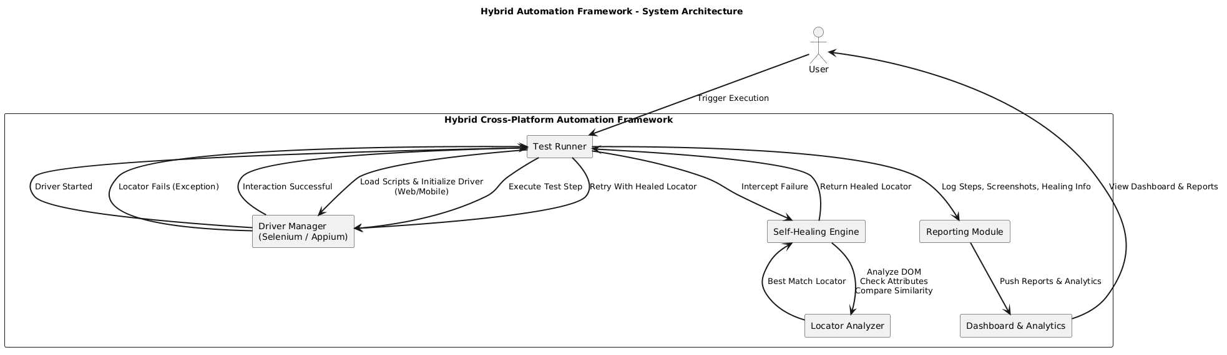
Explanation:
The user triggers execution → Test Runner loads scripts → DriverManager opens browser/device → While running steps, if a locator fails → Self-Healing Engine activates → Locator Analyzer compares DOM → Generates new locator → Execution continues → Reports generated → Dashboard updates.
This architecture ensures stability, low maintenance, and cross-platform support.

4.3 Data Flow Design (Logical Flow)
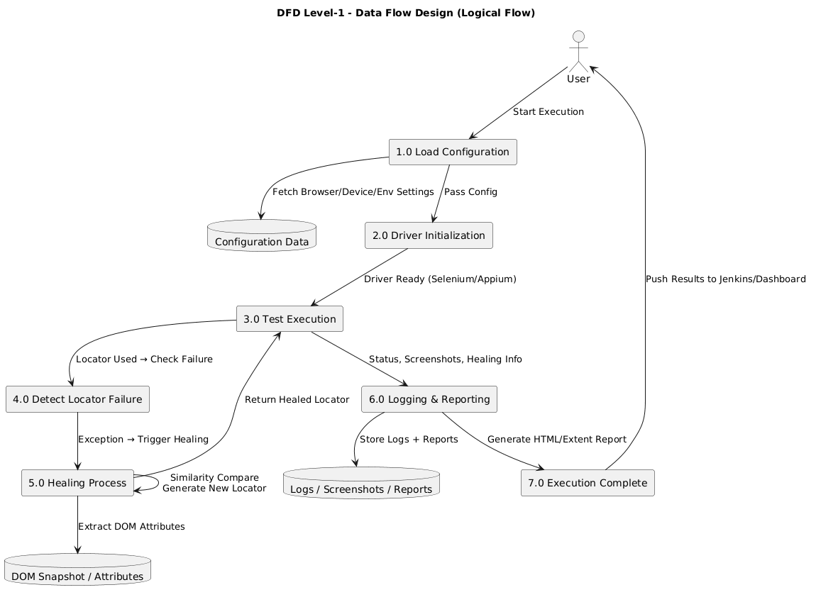
Explanation:
Step-1: Start Execution
- Framework loads configuration (browser/device/environment)
Step-2: Driver Initialization
- Selenium → Web
- Appium → Mobile
Step-3: Test Execution Flow
- Each step uses a locator
- Interaction attempts (click, sendKeys)
Step-4: Locator Failure Detected
- Exception caught
- Self-Healing Engine triggered
Step-5: Healing Process
- Extract DOM attributes
- Compare similarity with existing elements
- Generate new locator
- Retry operation
Step-6: Logging & Reporting
- Save screenshot
- Save logs
- Store healed locator
Step-7: Execution Complete
- Generate HTML/Extent report
- Push results to Jenkins or dashboard

4.4 Design Stages

4.4.1 Sequence Diagram (Description)
This diagram shows how different components of the hybrid automation framework interact during test execution.
The execution begins with the Test Runner. When the driver fails to find an element, the Self-Healing Engine is invoked. The engine requests the Locator Analyzer to generate the best possible locator. Once healed, the driver retries with the new locator, and finally the Report Manager logs the result.
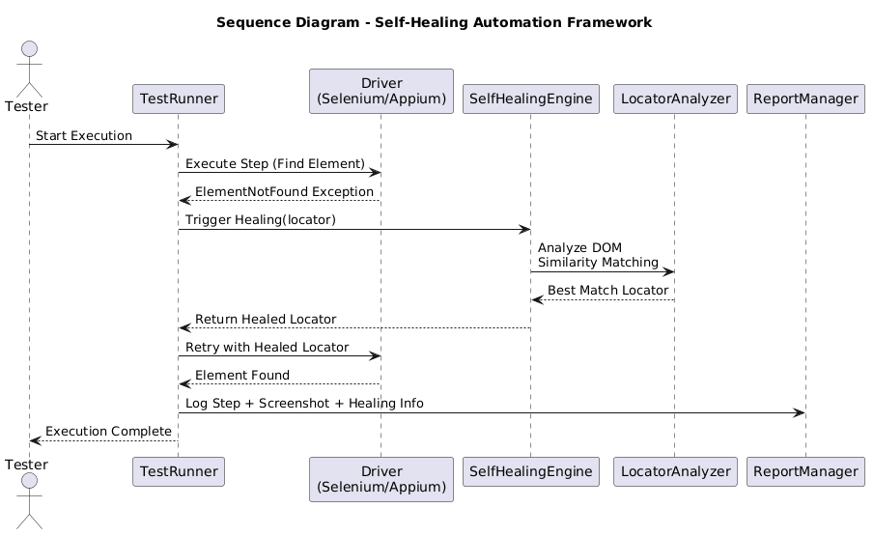

4.4.2 Collaboration Diagram (Description)
This diagram shows how objects collaborate and exchange messages during locator failure handling.
The TestRunner sends requests to the Driver and Self-Healing Engine.
The Self-Healing Engine collaborates with the Locator Analyzer.
Finally, the Report Manager logs the result.
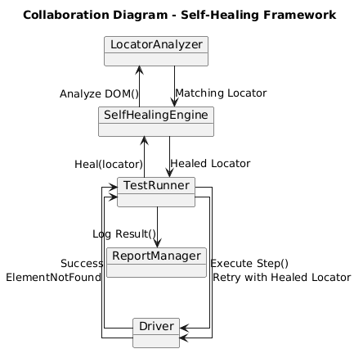

4.4.3 Class Diagram (Description)
This class diagram illustrates the main classes used in the framework and their relationships.
- TestRunner manages automation execution
- DriverManager initializes Selenium/Appium drivers
- SelfHealingEngine performs locator healing
- LocatorAnalyzer computes DOM similarity
- ReportManager handles reporting and screenshots
- ConfigManager loads settings

Relationships:
- TestRunner → uses DriverManager
- TestRunner → calls SelfHealingEngine
- SelfHealingEngine → depends on LocatorAnalyzer
- ReportManager → logs execution details
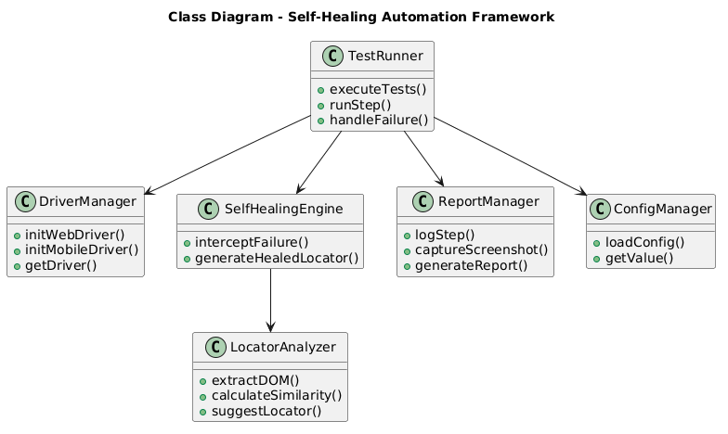

4.4.4 Activity Diagram (Test Flow)
This activity diagram represents the flow of automation execution:
- Start
- Load test and config
- Execute test step
- Check locator
- If fail → Healing → Retry
- Log results
- Generate reports
- End
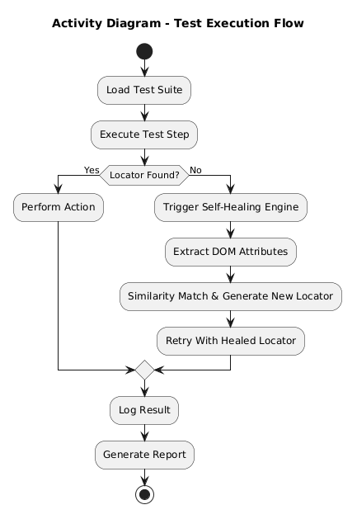

4.5 Design Rationale
The design ensures:
- Low maintenance: Healing reduces locator updates
- Cross-platform: One framework for both Web + Mobile
- Modularity: Each component is replaceable & extendable
- Scalability: Supports large enterprise test suites
- Reliability: Automatic fallback prevents flaky failures
- CI/CD friendliness: Works in pipelines without manual checks

